Jireh Community International School Quarterly Newsletter
“GIVE A CHILD A CHANCE”
P. O. BOX 5182, MONROVIA, LIBERIA Email: jirehcommunityschool@gmail.com Web: wwwjcischool.com Tel: +231 886 510 665; +231 886 510328
NOVEMBER 1, 2013 VOLUME I

The 2012/13 Academic year ended quite successfully with the graduation of fourteen (14) pupils from the KII Class, nine (9) pupils from Grade Nine, and three (3) pupils from Grade Twelve (12) – JCIS’S largest Senior High graduating class thus far. 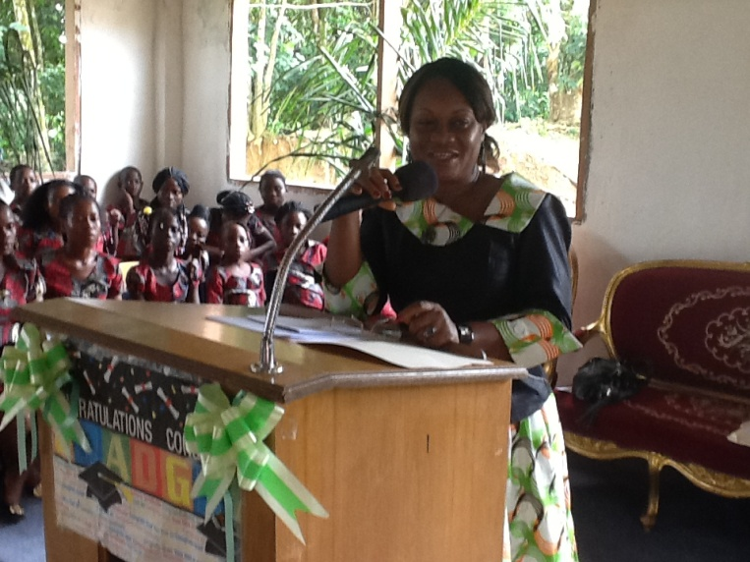 Her Honor, Justice Sie-A-Nyene Yuoh, Associate Justice, Republic of Liberia graced the occasion as the Keynote Speaker, and challenged the student body to be relentless in their pursuit and quest for education.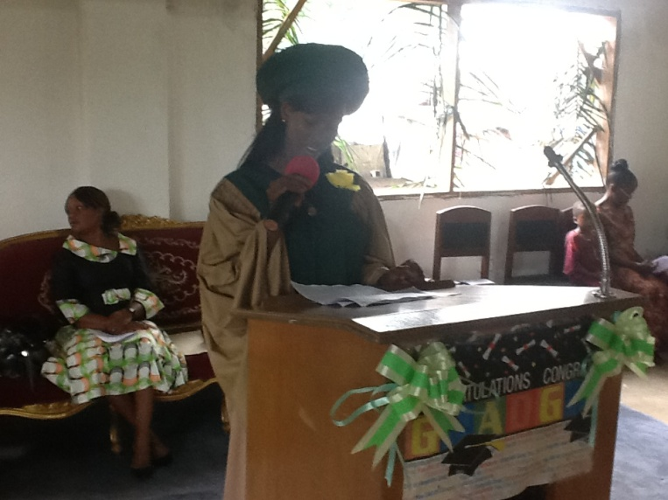 Miss Priscilla Lemgo, as Valedictorian of her class, addressed the student body, visiting families and friends about the importance of remaining in, and finishing school, to ensure a brighter future with more lucrative jobs. 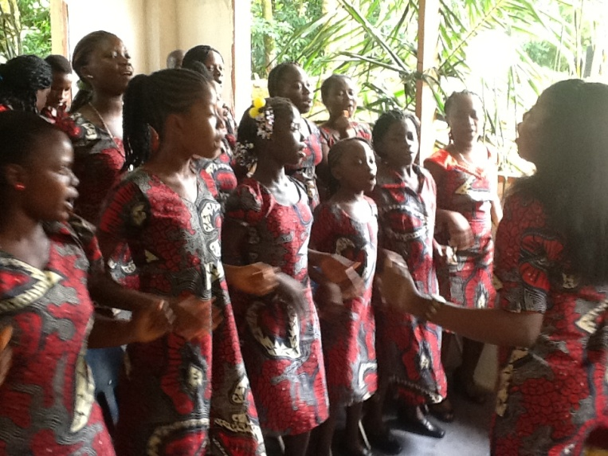
The ‘Voices of JCIS’ our dynamic Choral Group rendered many beautiful selections that made the day all the more exciting.
Majority of these young talented voices are from the surrounding villages. In addition to training them academically, we help them explore and develop their other natural gifting. Ninety – five percent (95%) of the forty-two – person Choral Group currently are residents of JCIS.
“Education is a treasure, once acquired, you take wherever you go.” - Lorince Arnette Taylor

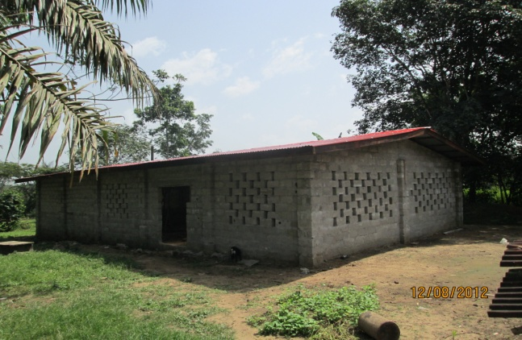
Commencement 2013 was held in our new, near – completion, multipurpose facility which is currently able to comfortably seat about two hundred (200) persons. A ‘dream come true!” This project was funded by a few sponsors, friends, and well-wishers. Thank you for your sacrificial gifts. As we say in Liberia, “Little is much when God is in it.” May God who blessed you to be a blessing to indigent children, continue to bless and prosper whatever you touch.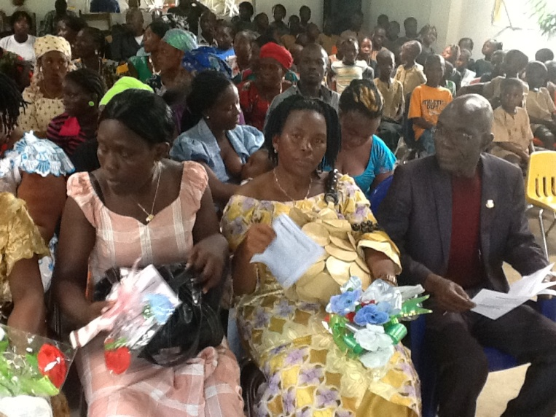

WAEC NEWS
All JCIS students at both Junior High and Senior High levels successfully passed the West Africa Examination Council (WAEC) exams. Congratulations to all of our students who worked so hard at becoming successful. We are proud of you all.

UNIVERSITY ENROLLED
Our goal to prepare future leaders for training at tertiary levels is unfolding. These JCIS graduates are successfully enrolled at two (2) tertiary institutions as follows:
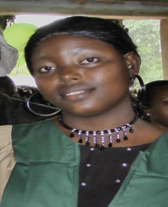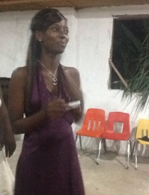
L – R Miss Rhoda Lemgo (2010 graduate) is a Freshman at the University of Liberia; Miss Lucretia Williams (2012 graduate) is a Sophomore at the University of Liberia and Miss Priscilla Lemgo (2013 graduate) is a student at AME University. WELL DONE!!!
Mr. Samuel Gbanegar is currently an employee of JCIS while he and Mr. Jacob Cooper await the up-coming entrance examination of the University of Liberia.

ACADEMIC YEAR 2013/14
We thank God for the commencement of another successful academic year. The year started off with a Thanksgiving Service held at the school’s campus on Monday, September 9, 2013.
Current enrollment is One hundred seventy-five (175), down by 23% from last year’s enrollment. Many parents are obligated, financially, to the school for two to three consecutive years and have opted to withdraw their children from school.
As an institution, we are overwhelmed with the financial burden of these poor rural families. Ninety-five percent (95%) of our total enrollment owe first semester tuition. We have given sixty (60) scholarships to the neediest children. Many still cannot pay their fees.
Please help! Any amount you can afford on a regular basis will go a long way to help educate these indigent school-aged children.

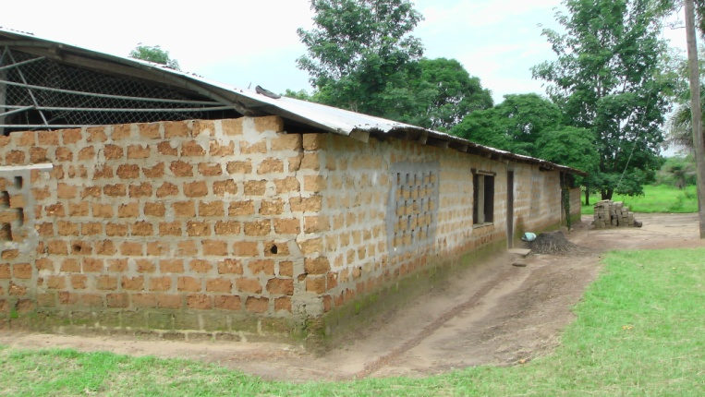
This is our current mud brick facility that we have already out grown. High achievers have already been trained within these mud-brick walls. An ultra modern facility with amenities such as modern science, computer, and music laboratories; a well equipped library, administrative offices, faculty lounge, etc could greatly, further, enhance the learning experiences of our pupils maximizing and ensuring the output of more high-achievers.

CURRENT NEEDS
Construct Multi-Facility Complex $150,000.00
30 Bunk beds 3,000.00
Boys’ Dormitory 10,000.00**
Solar System 8,000.00
Food & Basic Supplies 1,000.00 per Mon
Salaries 3,000.00 per Mon
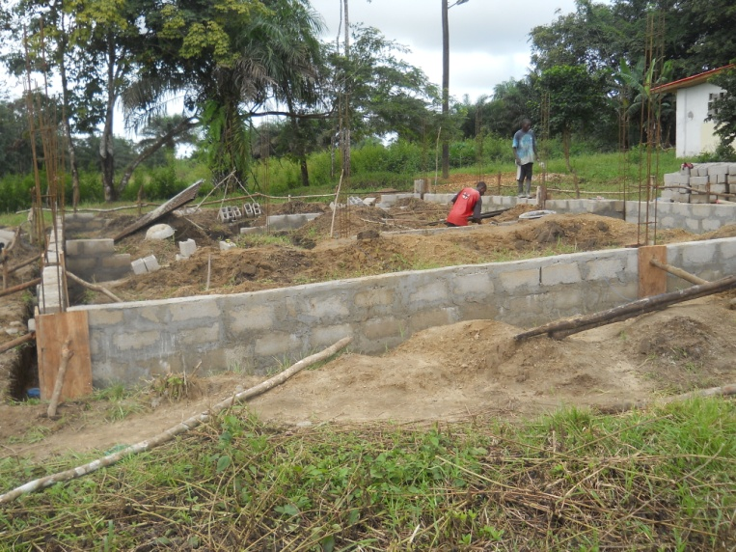
** Three thousand Dollars ($3,000) was raised in August, 2013 and construction of the boys’ dormitory is currently on-going.
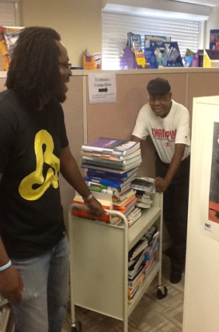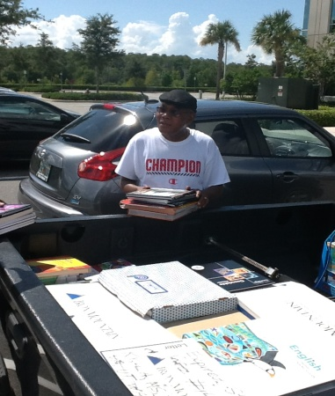
Thirteen (13) boxes out of an estimated 30 plus brand new books were donated to JCIS by the Publishers Houghton Mifflin Harcourt through the instrumentality of Mrs. Neo Monzili. These have been shipped to Liberia; however, we are seeking additional donations to ship the rest out of Florida. Thank you for giving to this worthy cause.
JCIS APPRECIATION EVENING (USA)
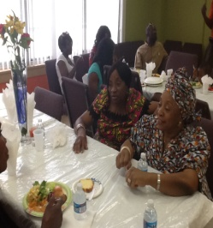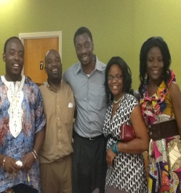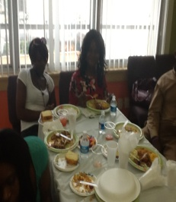
Special gratitude to Ms. Sophia Johnson, Mrs. Nicole Taylor..Mrs. Patricia Roberts, Mrs. Mariah Doe, and their entire team as well all invited participants for making this event a smashing success. God bless you all.
WORTH MENTIONING
Fifteen needy students received tuition assistance recently, when Senior Senator for Margibi County, Honorable Clarice A. Jah donated Fifteen Thousand Liberian Dollars (L$15,000) to assist with tuition for the most needy. Thank you, Senator Jah, for your generous gift.
Our deepest gratitude to all of our supporters who gave during the summer break as follows: Bishop Darlingston & Lady Chrys Johnson and the entire BWOM Church – Silverspring, MD family; Mr. Obi & Mrs. Ebere Okoye; Mr. Obi Gideon; Mr. Varney & Mrs. Nicole Taylor; Mr. Pitcho & Mrs. Neo Monzili, Ms. Sophia Johnson, & all others who have given to this cause significantly., may the LORD bless you abundantly.

GRADUATION 2013 PHOTO GALLARY
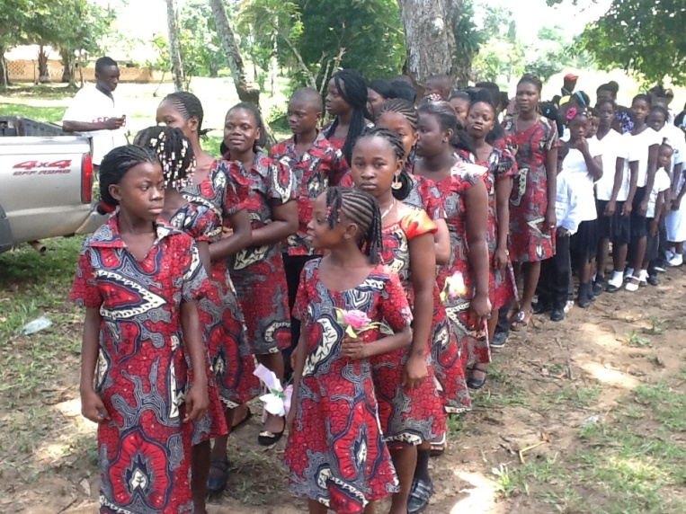
PROCESSIONAL HEADED BY SCHOOL CHOIR 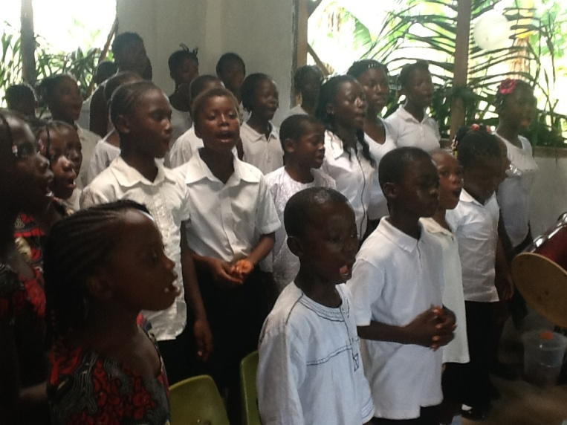ELEMENTARY CHOIR
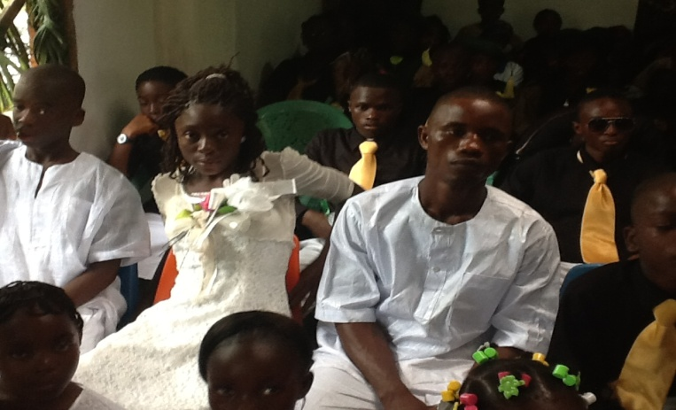

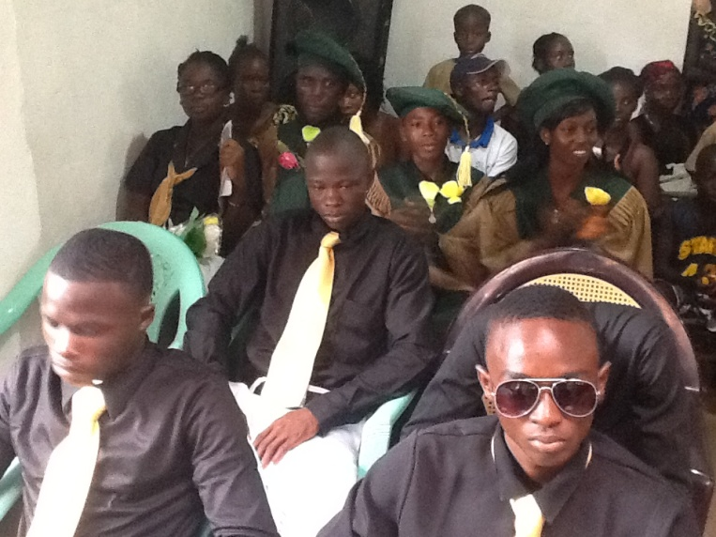 NINTH &TWELVETH GRADERS
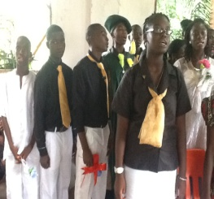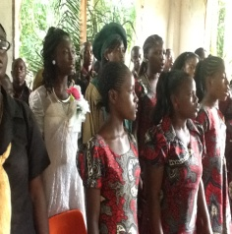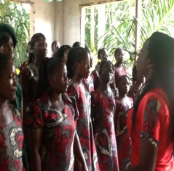
THE FULL CHOIR IN PEFORMANCE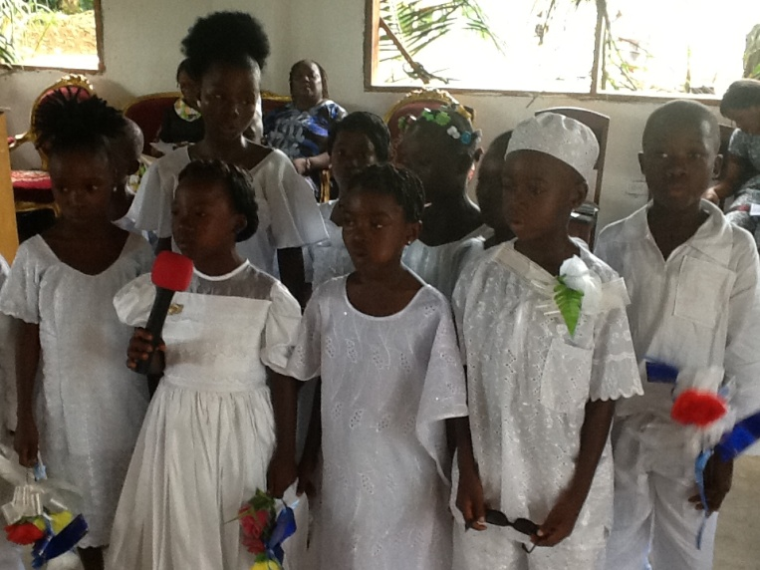
KINDERGARTEN II GRADUATES
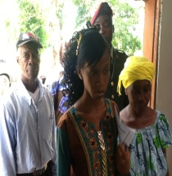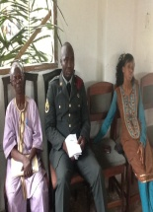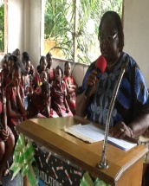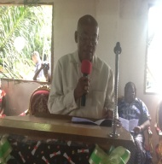
L – R SOME FACULTY; PRINCIPAL; & CHAIRMAN OF THE BOARD OF TRUSTEES

